**Encapsulate Feature**

|  |  |  |  |
| --- | --- | --- | --- |
| |  |  |  | | --- | --- | --- | | *a particular feature of a class is difficult to understand an control* |  | *move this particular feature into a class of its own* | |

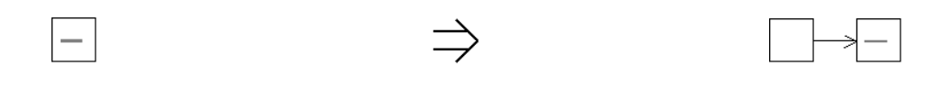

**Context:**

Encapsulation is a powerful mechanism to control the number of code adjustments required in order to perform a refactoring. [Encapsulate Feature](https://web.archive.org/web/20090914100944/http:/www.refactoring.be/thumbnails/rtn-ef.html) is a natural preparation step prior to moving or refactoring a certain feature.

[Encapsulate Feature](https://web.archive.org/web/20090914100944/http:/www.refactoring.be/thumbnails/rtn-ef.html) is an example of [Introduce Indirection](https://web.archive.org/web/20090914100944/http:/www.refactoring.be/thumbnails/rtn-ii.html).

See also :[Inline Feature](https://web.archive.org/web/20090914100944/http:/www.refactoring.be/thumbnails/rtn-if.html), *Replace Method With Method Object[Fowler]*, *Extract Class[Fowler]*, *Extract Method[Fowler]*, *Replace Data Value With Object[Fowler]*, *Replace Type Code With Class[Fowler]*